6. Perform basic video processing operations on the captured video
AIM:- Read captured video in python and display the video, in slow
motion and in fast motion
PROGRAM
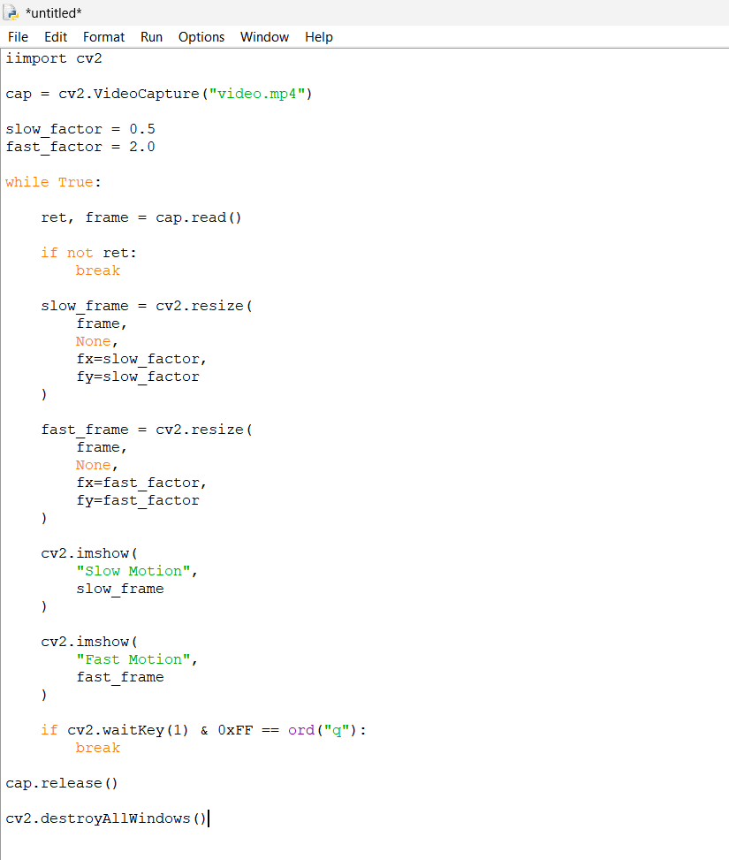

Output
